**🛍️Retail Sales Analysis Report**

**Tool Used:** MySQL   
**Database:** project.retail_sale_analysis

**Project Overview**

This project focuses on analysing retail sales data using SQL. The goal is to explore customer behavior, product performance, and temporal sales trends to help guide business decision-making.

**Create database:**

CREATE DATABASE project;

Use project;

**Create Table:**

DROP TABLE IF EXISTS retail_sale_analysis;

CREATE TABLE retail_sale_analysis

(

transactions_id INT PRIMARY KEY,

sale_date DATE,

sale_time TIME,

customer_id INT,

gender VARCHAR(15),

age INT,

category VARCHAR(15),

quantity INT,

price_per_unit FLOAT,

cogs FLOAT,

total_sale FLOAT

);

SELECT * FROM retail_sale_analysis LIMIT 10;

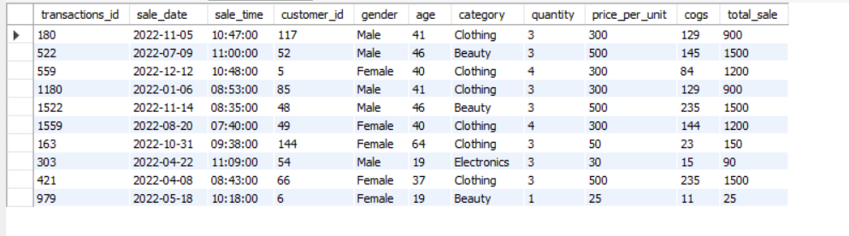

SELECT COUNT(*) FROM retail_sale_analysis;



**Data Cleaning Summary**

* All NULL values in critical fields were identified and deleted.
* Columns were correctly typed (e.g., sale_date as DATE, sale_time as TIME).
* Column quantiy was corrected to quantity.

SELECT * FROM retail_sales_analysis

WHERE

transactions_id IS NULL

OR

sale_date IS NULL

OR

sale_time IS NULL

OR

gender IS NULL

OR

category IS NULL

OR

quantity IS NULL

OR

cogs IS NULL

OR

total_sale IS NULL;

**Deleting Null values:**

DELETE FROM retail_sale_analysis

WHERE

transactions_id IS NULL

OR

sale_date IS NULL

OR

sale_time IS NULL

OR

gender IS NULL

OR

category IS NULL

OR

quantity IS NULL

OR

cogs IS NULL

OR

total_sale IS NULL;

**Data Exploration:**

**How many sales we have?**

SELECT COUNT(*) as total_sale FROM retail_sale_analysis;



**-- How many unique customers we have ?**

SELECT COUNT(DISTINCT customer_id) as total_sale FROM retail_sale_analaysis;



SELECT DISTINCT category FROM retail_sale_analysis;

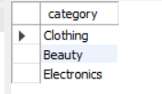

**-- Data Analysis & Business Key Problems & Answers**

**-- Analysis & Findings**

-- Q.1 Write a SQL query to retrieve all columns for sales made on '2023-10-07

-- Q.2 Write a SQL query to calculate the total sales (total_sale) for each category.

-- Q.3 Write a SQL query to find the average age of customers who purchased items from the 'Beauty' category.

-- Q.4 Write a SQL query to find all transactions where the total_sale is greater than 1000.

-- Q.5 Write a SQL query to find the total number of transactions (transaction_id) made by each gender in each category.

-- Q.6 Write a SQL query to calculate the average sale for each month. Find out best selling month in each year

-- Q.7 Write a SQL query to find the top 5 customers based on the highest total sales

-- Q.8 Write a SQL query to find the number of unique customers who purchased items from each category.

-- Q.9 Write a SQL query to create each shift and number of orders (Example Morning <=12, Afternoon Between 12 & 17, Evening >17)

Q.1 Write a SQL query to retrieve all columns for sales made on '2023-10-07

**SELECT * FROM retail_sale_analysis WHERE sale_date = '2023-10-07';**

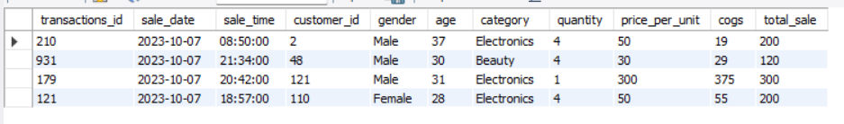

Q.2 Write a SQL query to calculate the total sales (total_sale) for each category.

**SELECT category,**

**SUM(total_sale) as net_sale,**

**COUNT(*) as total_orders**

**FROM retail_sale_analysis GROUP BY 1;**

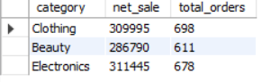

Q.3 Write a SQL query to find the average age of customers who purchased items from the 'Beauty' category.

**SELECT ROUND(AVG(age), 2) as avg_age FROM retail_sale_analysis WHERE category = 'Beauty';**

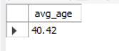

Q.4 Write a SQL query to find all transactions where the total_sale is greater than 1000.

**SELECT * FROM retail_sale_analysis WHERE total_sale > 1000 LIMIT 10;**

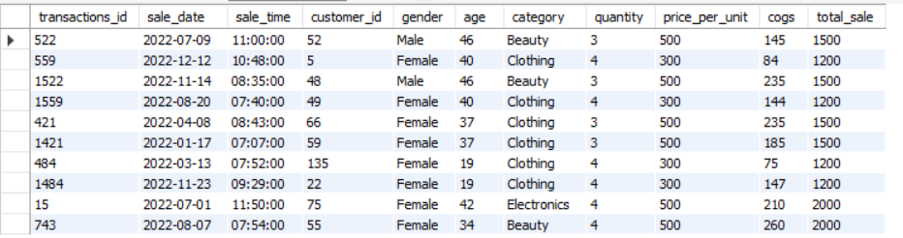

Q.5 Write a SQL query to find the total number of transactions (transaction_id) made by each gender in each category.

**SELECT category, gender, COUNT(*) as total_trans**

**FROM retail_sales**

**GROUP BY**

**category,**

**gender**

**ORDER BY 1**

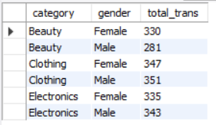

Q.6 Write a SQL query to calculate the average sale for each month. Find out best selling month in each year

**SELECT year, month,avg_sale FROM (**

**SELECT**

**EXTRACT(YEAR FROM sale_date) as year,**

**EXTRACT(MONTH FROM sale_date) as month,**

**AVG(total_sale) as avg_sale,**

**RANK() OVER(PARTITION BY EXTRACT(YEAR FROM sale_date) ORDER BY AVG(total_sale) DESC) as _rank**

**FROM retail_sale_analysis**

**GROUP BY 1, 2**

**) as t1**

**WHERE _rank = 1;**

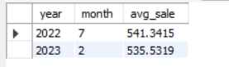

Q.7 Write a SQL query to find the top 5 customers based on the highest total sales

**SELECT**

**customer_id,**

**SUM(total_sale) as total_sale_analysis**

**FROM retail_sale_aanlysis**

**GROUP BY 1**

**ORDER BY 2 DESC**

**LIMIT 5;**

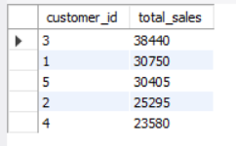

Q.8 Write a SQL query to find the number of unique customers who purchased items from each category.

**SELECT category,**

**COUNT(DISTINCT customer_id) as cnt_unique_cs**

**FROM retail_sale_analaysis**

**GROUP BY category;**

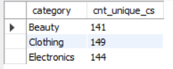

Q.9 Write a SQL query to create each shift and number of orders (Example Morning <12, Afternoon Between 12 & 17, Evening >17)

**WITH hourly_sale**

**AS**

**(**

**SELECT *,**

**CASE**

**WHEN EXTRACT(HOUR FROM sale_time) < 12 THEN 'Morning'**

**WHEN EXTRACT(HOUR FROM sale_time) BETWEEN 12 AND 17 THEN 'Afternoon'**

**ELSE 'Evening'**

**END as shift**

**FROM retail_sales**

**)**

**SELECT**

**shift,**

**COUNT(*) as total_orders**

**FROM hourly_sale**

**GROUP BY shift;**

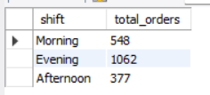

**Key Takeaways**

* **Top Categories:** Clothing and Beauty are frequent purchase categories.
* **Customer Insights:** Average age of Beauty buyers is around mid-30s.
* **Peak Sales Periods:** Seasonal trends can be identified via best-selling months.
* **Premium Purchases:** A number of transactions exceeded ₹1000.
* **Time of Day Sales:** Most sales occurred in the Afternoon and Evening.